**Banking Platform**

**Stored Structures**

Vaishnavi

27/6/2025

This PL/SQL program defines procedures to automate key banking operations such as applying monthly interest to savings accounts, updating employee bonuses by department, and securely transferring funds between accounts.

**Objective:**

* **Apply Monthly Interest:** Calculate and update a 1% interest on all savings account balances.
* **Update Employee Bonuses:** Increase salaries of employees in a specified department based on a given bonus percentage.
* **Transfer Funds Securely:** Ensure safe transfer of funds between two accounts with sufficient balance checks.

**Implementation**

First Create a Table for Accounts and Employees and Insert the values into it.

**Scenario 1:**

Apply 1% interest to all **SAVINGS** account balances.

CREATE OR REPLACE PROCEDURE ProcessMonthlyInterest AS

BEGIN

UPDATE ACCOUNTS

SET BALANCE = BALANCE + (BALANCE * 0.01)

WHERE ACCOUNT_TYPE = 'SAVINGS';

DBMS_OUTPUT.PUT_LINE('Monthly interest processed for all savings accounts.');

COMMIT;

END;

/

To run this process,

BEGIN

ProcessMonthlyInterest;

END;

/

**Scenario 2:**

Give bonus percentage (parameter) to employees of a specific department

CREATE OR REPLACE PROCEDURE UpdateEmployeeBonus(

dept_id IN NUMBER,

bonus_percent IN NUMBER

) AS

BEGIN

UPDATE EMPLOYEES

SET SALARY = SALARY + (SALARY * bonus_percent / 100)

WHERE DEPARTMENT_ID = dept_id;

DBMS_OUTPUT.PUT_LINE('Bonus applied to department: ' || dept_id);

COMMIT;

END;

/

To run this process,

BEGIN

UpdateEmployeeBonus(101, 10);

END;

/

**Scenario 3:**

Move amount from one account to another, only if balance is sufficient.

CREATE OR REPLACE PROCEDURE TransferFunds(

from_acc_id IN NUMBER,

to_acc_id IN NUMBER,

amount IN NUMBER

) AS

from_balance ACCOUNTS.BALANCE%TYPE;

BEGIN

-- Check balance

SELECT BALANCE INTO from_balance

FROM ACCOUNTS

WHERE ACCOUNT_ID = from_acc_id;

IF from_balance < amount THEN

RAISE_APPLICATION_ERROR(-20001, 'Insufficient balance in source account.');

END IF;

-- Debit source account

UPDATE ACCOUNTS

SET BALANCE = BALANCE - amount

WHERE ACCOUNT_ID = from_acc_id;

-- Credit destination account

UPDATE ACCOUNTS

SET BALANCE = BALANCE + amount

WHERE ACCOUNT_ID = to_acc_id;

DBMS_OUTPUT.PUT_LINE('Transferred ₹' || amount || ' from Account ' || from_acc_id || ' to Account ' || to_acc_id);

COMMIT;

END;

/

To run this process,

BEGIN

TransferFunds(1001, 1002, 500);

END;

/

**Output:**

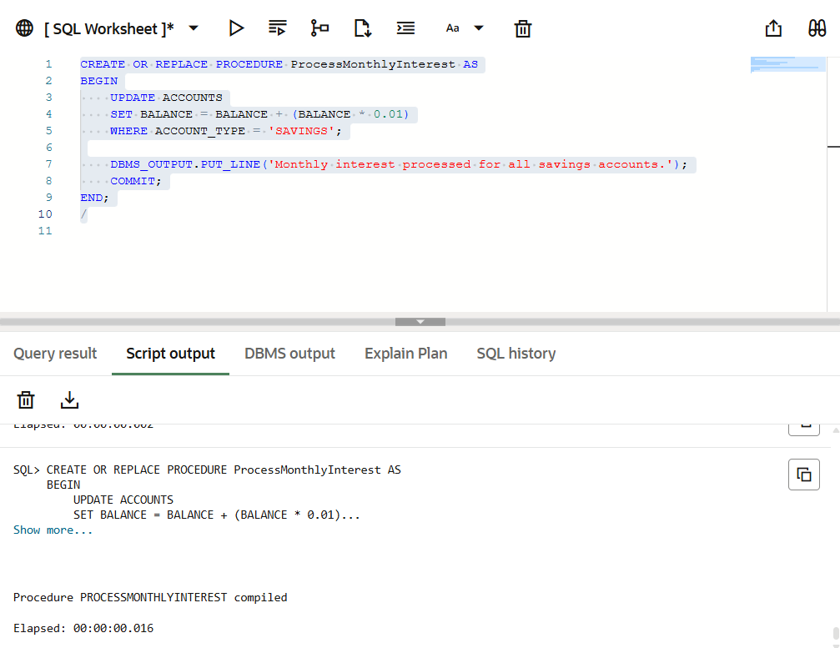

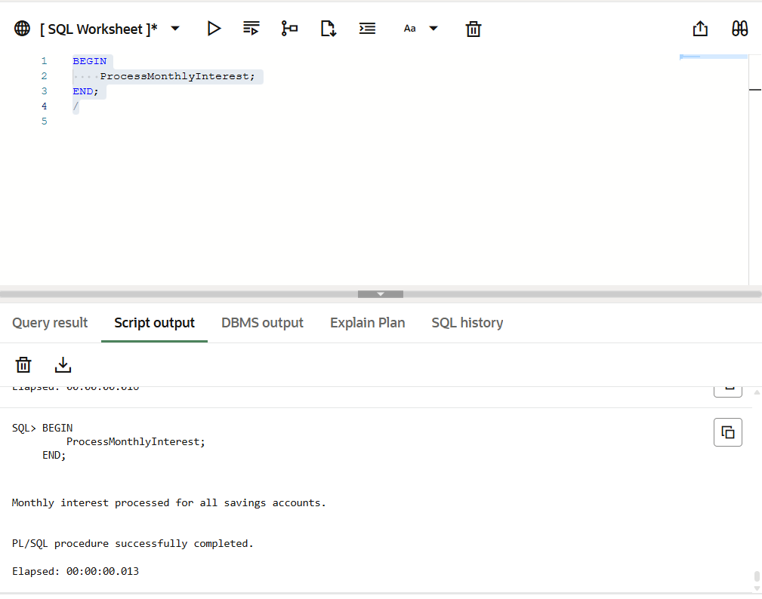

**Asd**

